**THEORY OF COMPUTATION**

**k.yaswanth DAY 1**

**192111638**

# Design DFA to accept bcaaaaaaaaaaaaaa, bc, and c

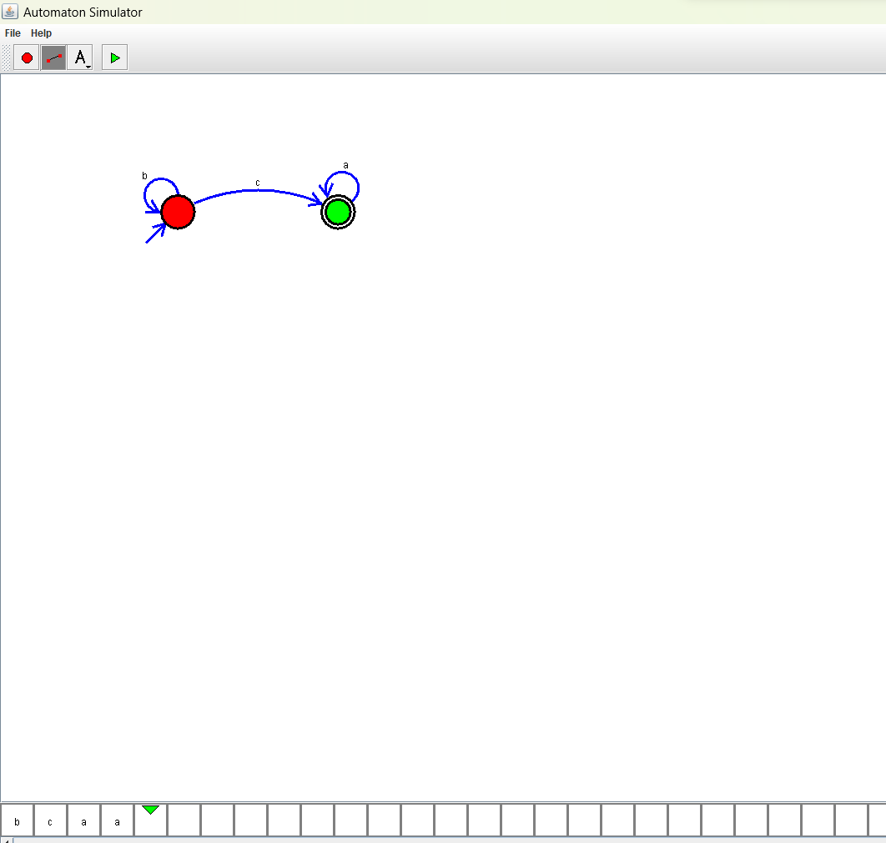

# 2.Design NFA to accept aaaaaa

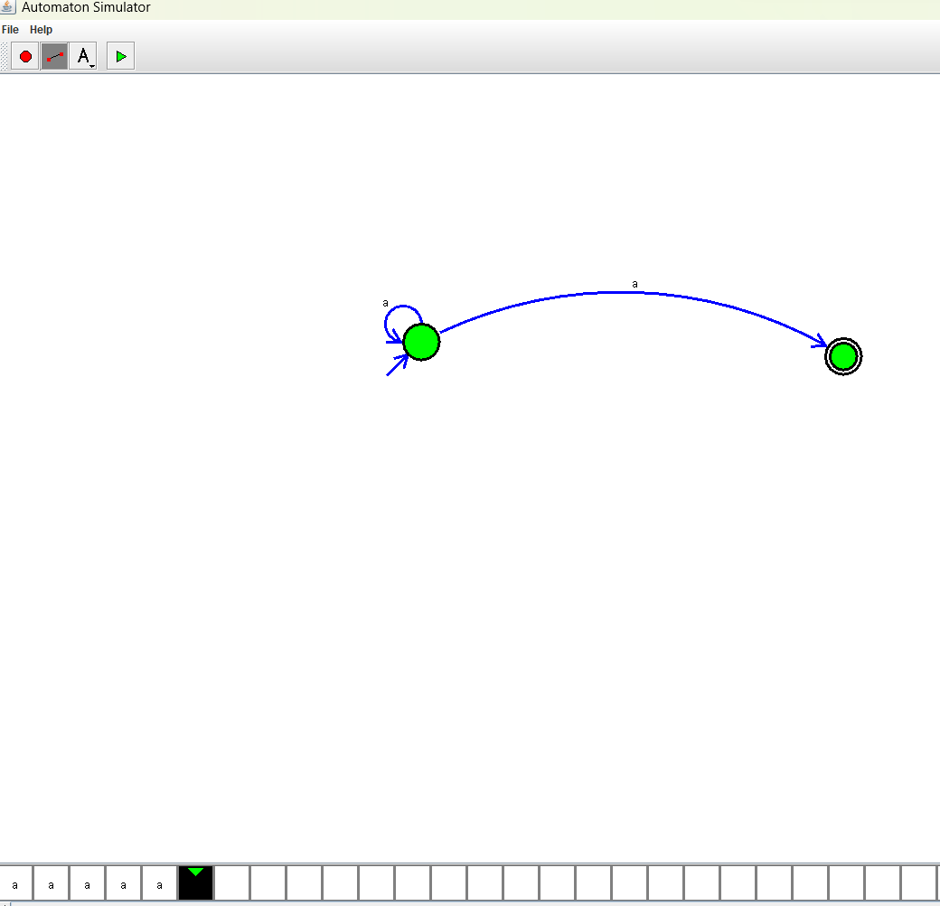

# 3.Design PDA for the input a^nb^n

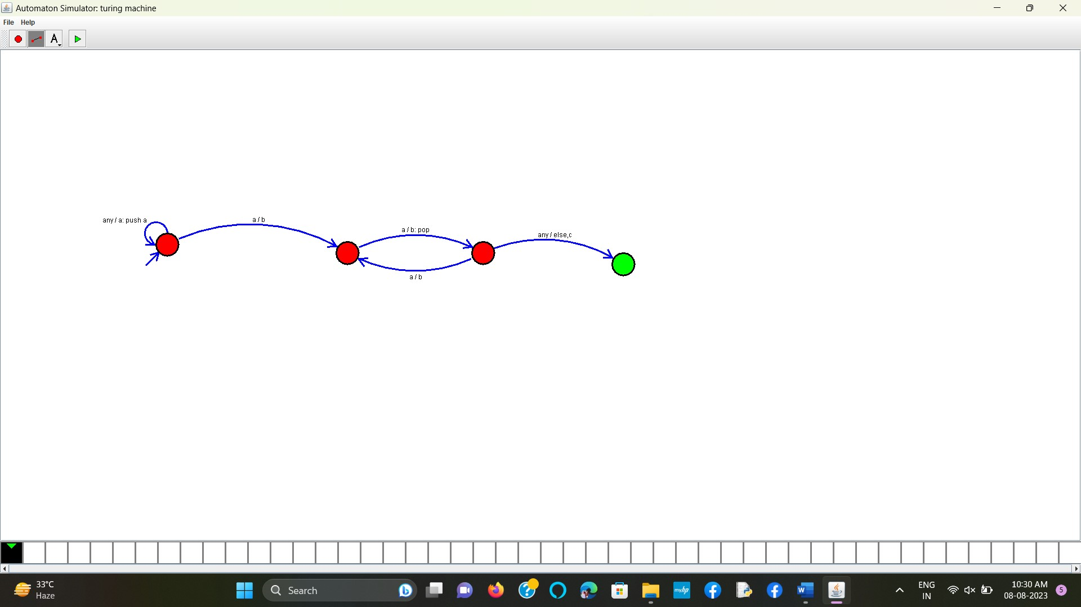

# 4.Design Tm For input a^nb^n

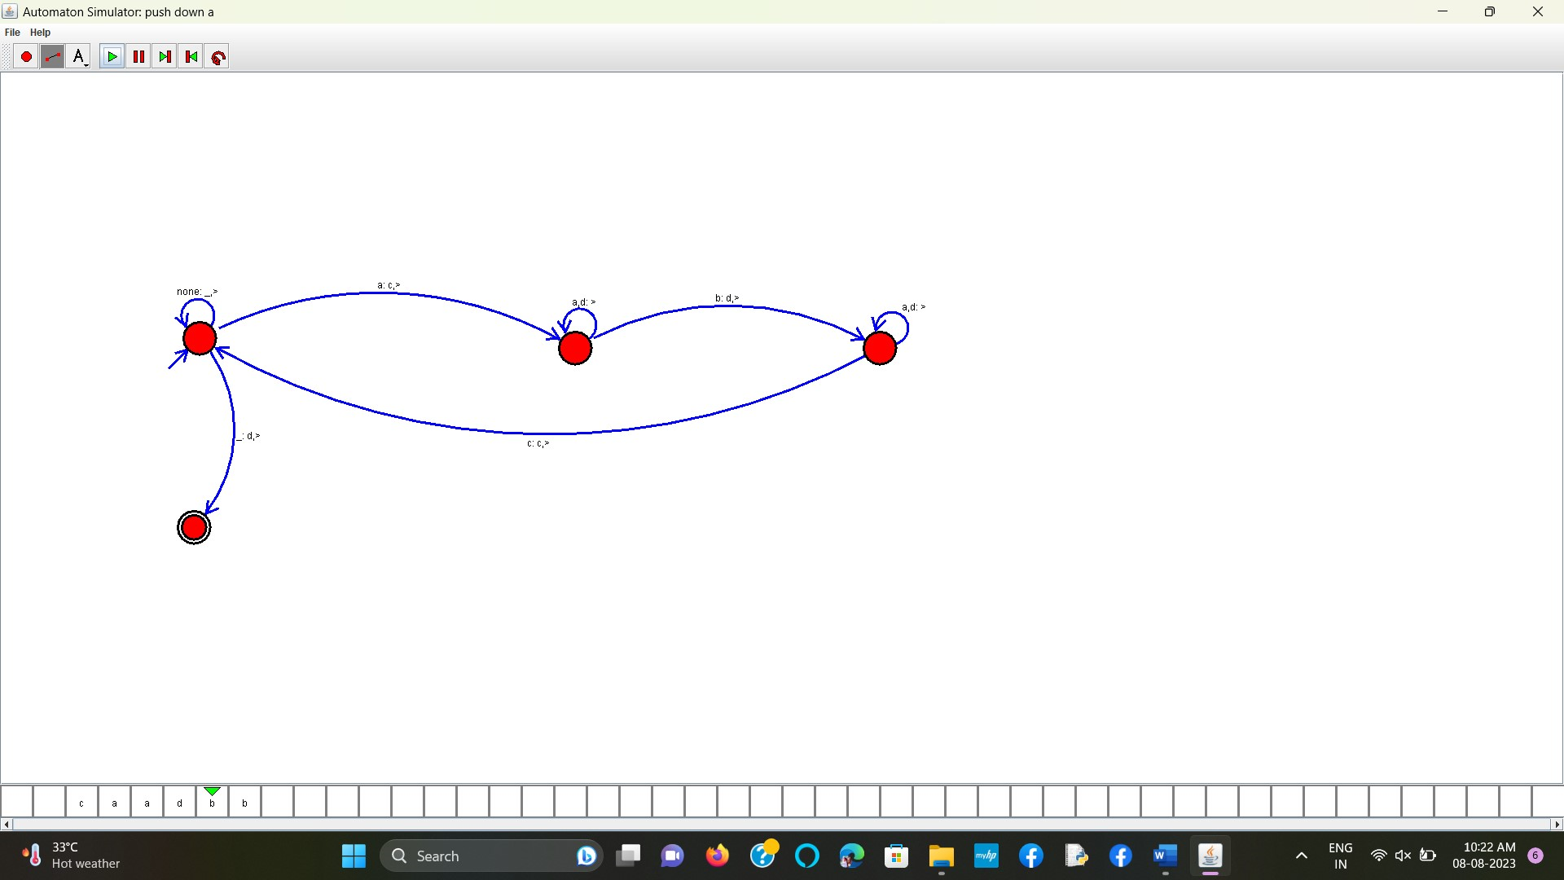

# 5 .Design PDA for input aabbbbc ( L=a^nb^2n)

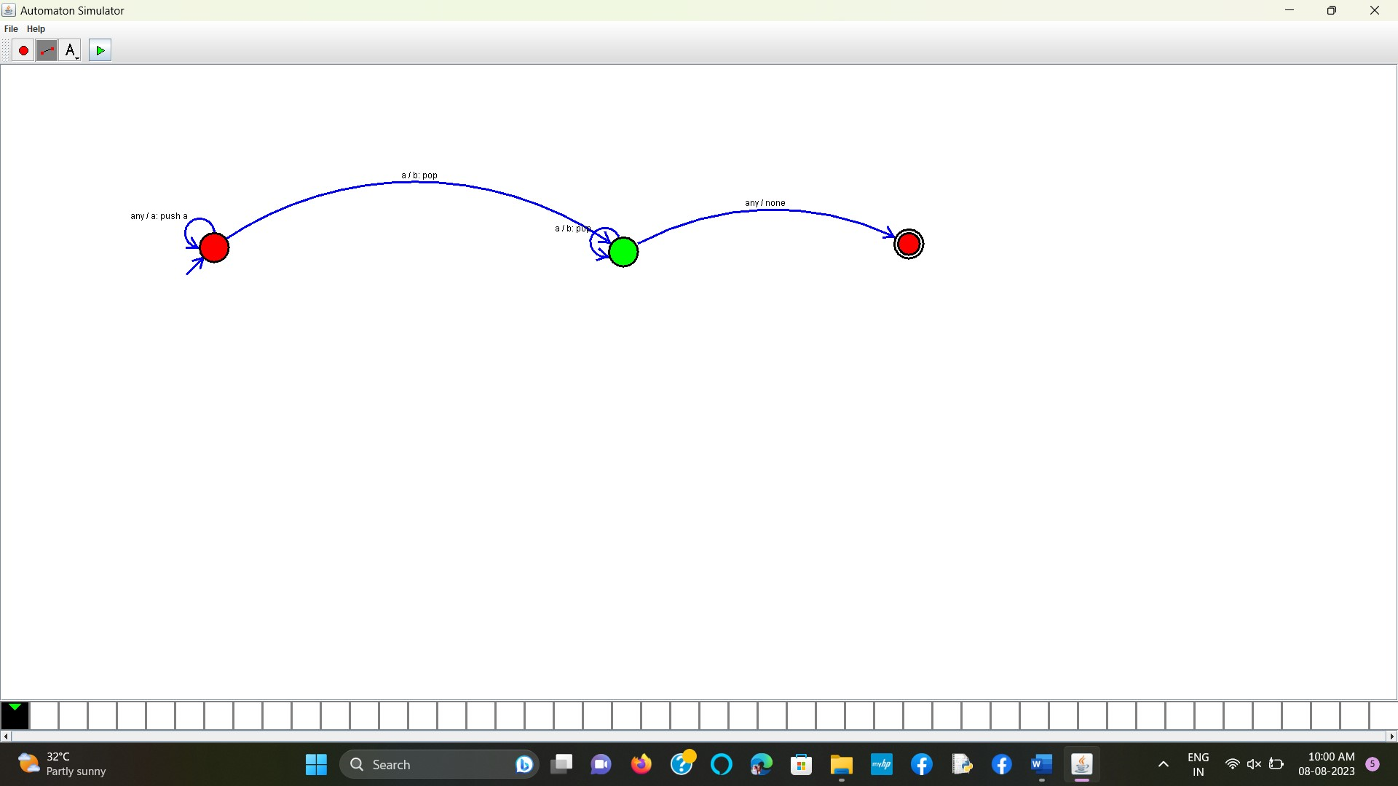

# 6.TM Simulation for Palindrome W= ababa c

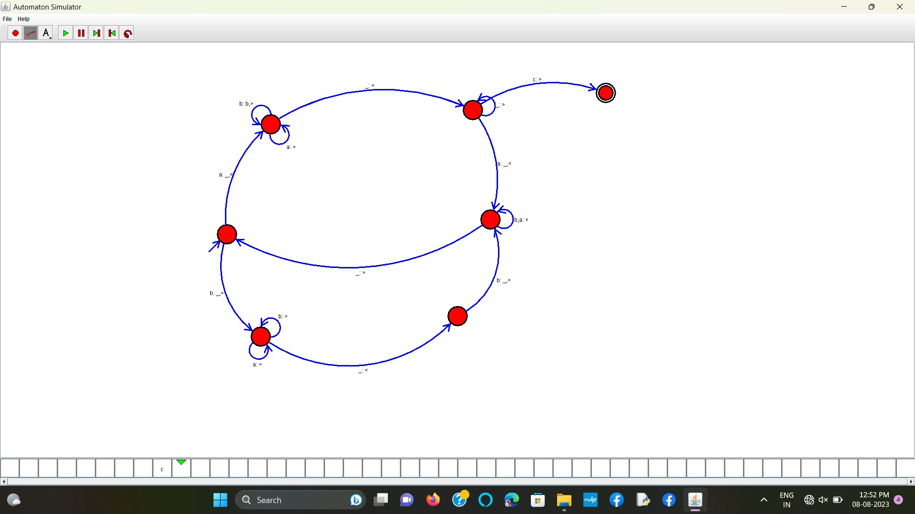

# 7.Design TM to perform addition of following

# W= aa + aaaa

# After Addition of a’s = aaaaaa

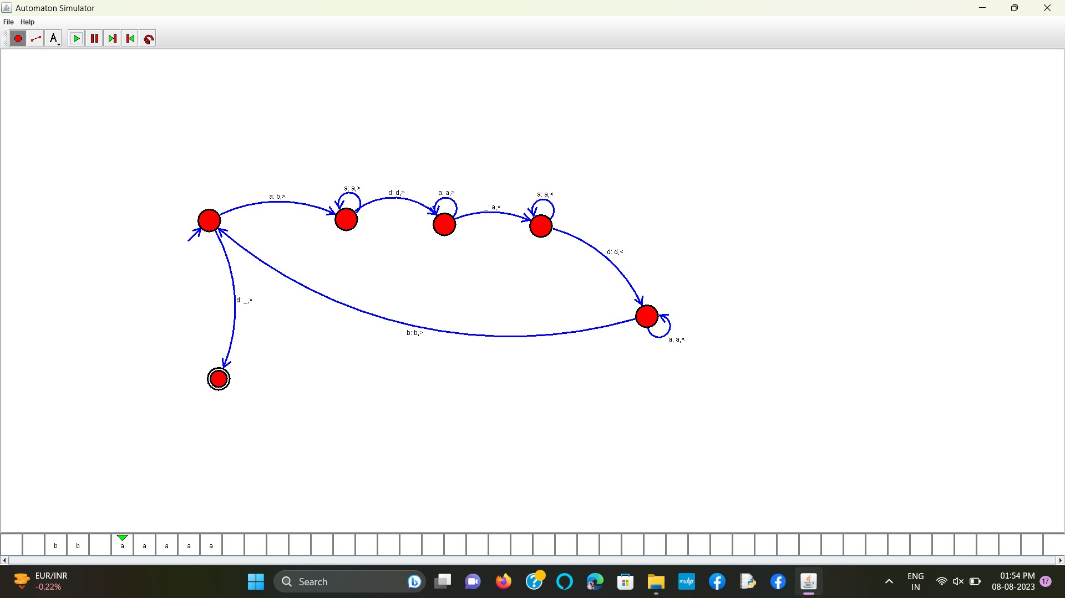

# 8.Design TM to perform subtraction

# W= aaa-aa

# The Result of Subtraction is = a

